|  |
| --- |
| CPU with binary numbers and blueprint |
| POE Documentation  Code addicts |
| |  |  |  | | --- | --- | --- | | Mehluli Ofentse Booi | 9/27/24 | XCAD7319 | |

**Pathway: Work Integrated Learning 3**

**Module Code: XBCAD7319**

**Lecturer: Mmaphuti Matau**

**POE Documentation**

**Team name: Code addicts**

**ST10028039 – Mehluli Ofentse Booi Leader**

**ST10209476 – Lesego Ramosa**

**ST10092086-Lwazi Mesatywa**

Scrum Agile Board: <https://trello.com/invite/b/66f3ec71915caa196897689b/ATTIef1728e5d554052d2e321f8c6618193111439D30/code-addicts>

Source Code Repository: <https://github.com/Mehlulibooi/Code-addicts.git>

Contents

1. INTRODUCTION 3

1.1 Agreement of Work 3

1.2 Definition of Ready (DoR) 3

1.3 Definition of Done (DoD) 4

Requirement 4

User Roles 4

Admin: 4

Registered User Role: 5

Guest/Anonymous User role 5

Developer Role 5

User Stories 6

User Experience Journey Map 7

Non- functional requirements 8

Portability 8

Scalability 8

Usability 9

Reliability 9

References 10

# 1. INTRODUCTION

TK and NZ Trading and Projects PTY LTD are a company based in the Johannesburg which specialises in rendering transportation services. They offer a range of transport options from home removals to delivering packaging materials. The company is quite new and is lacking in certain areas. One of the areas is a weak online presence when compared to the competitors. Therefore, the team has been tasked to develop a website where prospective clients may visit and pay for their desired services.

## 1.1 Agreement of Work

Furthermore, the team comprises of three people, and work has been divided amongst the members based on the expertise. The first member Mehluli Booi has been assigned to be the scrum master of the group and has been assigned to DevOps and quality assurance and testing. He is responsible for ensuring that the infrastructure is running and can keep up with the demand of an increase in the number of active users and that security measures are in place. The second member is Lesego Ramosa who will be the backend developer for this project. His job is to deal with behind-the-scenes processes that are not seen by the registered user, such as server-side logic and the managing of the database. He will also oversee the creation and the integration of the API that is to be used in the application. The third member is Lwazi Mesatywa who will be the frontend developer of the project. His role is to develop and design the user interface (UI) of the system, which is the first and only thing users will be interacting with on the system. He will ensure that the website looks good enough that the users will keep returning to the site.

## 1.2 Definition of Ready (DoR)

The Definition of Ready is a set of agreed upon criteria that a project backlog item must meet to qualify for development, meaning that it is ready to be worked on (Thannermalai, 2019)The team has decided to breakdown their definition of ready into 9 categories which every feature, user story and task should meet to be approved for development. The criteria are clear definition, identification of dependencies and blockers, clear business value, designs and UX are ready, technical requirements and specifications are provided, proper estimation was made, defined criteria for testing, resource availability confirmed, and stakeholder approval.

Therefore, for a task to be considered ready, the user story or action and desired action should be clearly outlined. The dependencies on resources should be given and whether the task is aligned with the business goals and objectives before allocating resources. Mock up screens should be there along with the technical requirements of the chosen task, such as database models and API contracts. Value estimations based on risk, complexity and required effort are made by the team to check if the suggested task is worth it in the long run and quality acceptance tests are then provided to make sure the tester knows how to assess the functionality of the feature. Stakeholders should give their approval, and the team should check if they have sufficient resources to complete the task whether it be time or human resources.

## 1.3 Definition of Done (DoD)

The Definition of Done is a set of exit criteria which an item should meet to ensure that it is done and needs no further work done (Thannermalai, 2019)The team has opted to go for 7 prerogatives the task or the entire project should meet to be considered as complete. These are core functionality is implemented and tested, front and backend are completed, testing and quality assurance have been done, deployment and infrastructure is prepared, documentation and post launch maintenance plans have been drawn up.

Furthermore, for a task to be completed, the core functionality needs to be there and tested and both the development of the front and backends should be thoroughly completed. The infrastructure required for a successful deployment should be in place and the quality of the task needs to be tested and approved. Finally, all documentation concerning the task needs to be completed such as the technical documentation and the user documentation. This needs to be in conjunction with the preparation and completion of the post launch maintenance plans before being considered by the team as done.

# Requirement

## User Roles

For this web application we have decide to go with these five User for this application to help ensure security, control and an organized workflow: (Nuclino, 2024)

### Admin:

**Permissions:**

* Unrestricted access to all the system settings and features.
* Monitor usage and generate reports
* Create, update, delete user accounts and roles.
* Manage all data, including viewing, editing and deleting records.
* Control of system setting, backups and logs

**Use Case:**

* Admins are people who will be responsible for overseeing management and maintenance of the application.

### Registered User Role:

**Permissions:**

* Access to basic features, such as creating profile submitting contract forms
* Being able to leave reviews and start rates
* Limited access to edit and view their personal data

**Use Case:**

* Registered users are customers or regular users who access to features that require accounts like booking a service.

Guest/Anonymous User role:

**Permissions:**

* Cannot create, edit, or delete any data
* Limited access to view public content like be allow see landing page but not being to request services
* No account personalized features like the profile features, comments and reviews

**Use Case:**

* Guest are able to browse the web application but have to register for more features.

Developer Role:

**Permissions:**

* Access to developer tool such as code repositories, system configurations and debugging logs
* Limited access to admin settings but has privileges related to maintenance and development
* Deploy updates or roll back changes

**Use Case:**

* To work the technical aspect of the application like bug fixes and updates.

## User Stories

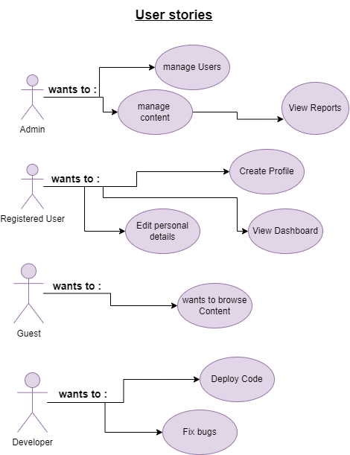

Figure 1: use case for web app

## User Experience Journey Map

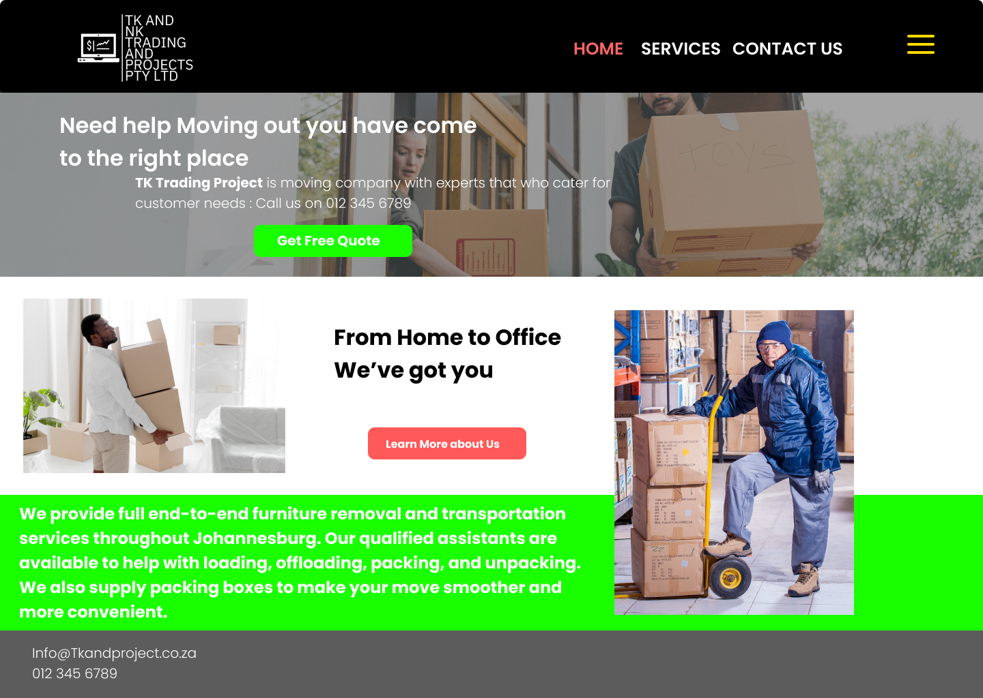

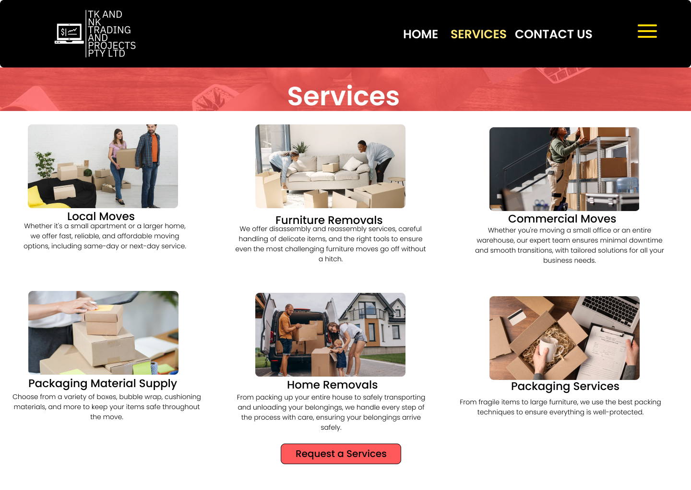

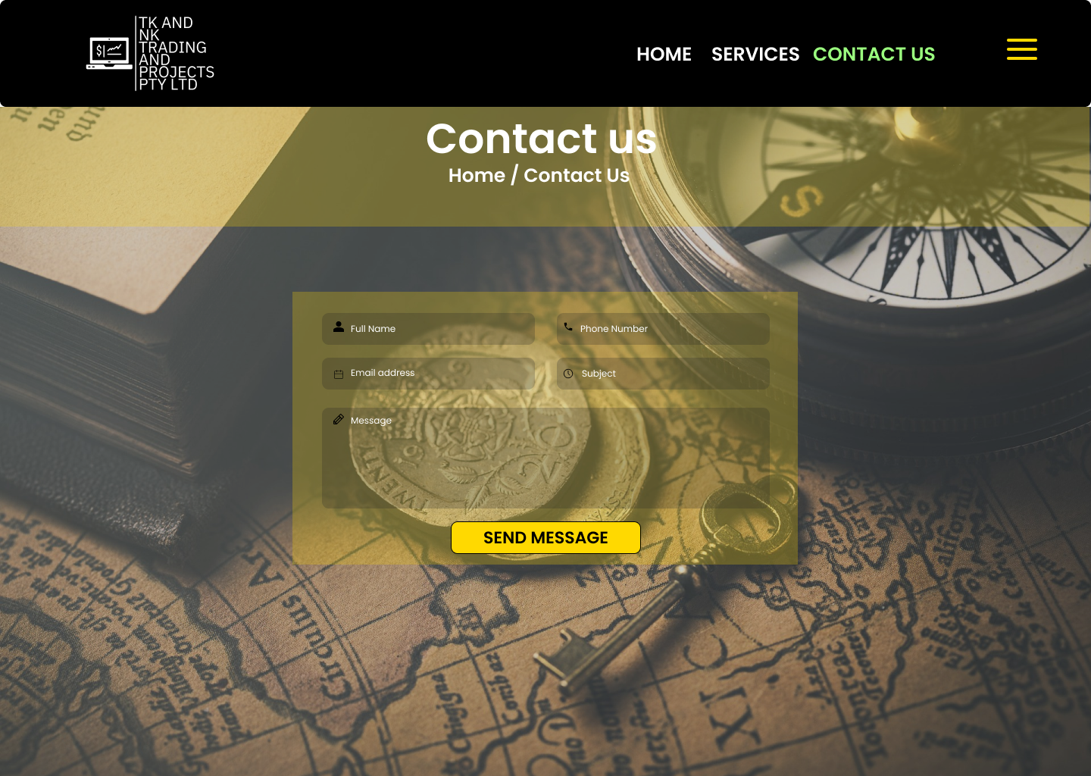

We have developed simple web pages designed for easy user access, helping people quickly find information about our moving company. The website focuses on providing essential details, such as who we are, the services we offer, and an effortless way for users to contact us and reach out for assistance.

# Non- functional requirements

Non-functional requirements define how a system operates rather than what it does. They focus on performance, reliability, and usability, helping to shape the system's overall quality and constraints. Below are the key non-functional requirements for this web application: (altexsoft, 2023)

Portability - ensuring that the web app focuses on having put portability as a requirement is important as it gives the business or company a chance to get users attention from the phone in their hands to the desktop at home and having browser support. (Nuclino, 2024)

Scalability - is one of the most important requirements as this is an ever-growing business so the web application is to needs grow to be able to handle the business's needs and digital foot traffic.

**Device responsiveness** to support horizontal and vertical scaling

Usability – is a requirement the web app needs to have like **ease of use** with the UI for users can navigate with little to no guidance.

**Accessibility** standards so that user with disabilities can use the system effectively

**Multilingual system** to accommodate all users from different regions and languages.

Reliability –

System is to have a robust design that allows us to keep the website running 99% of the time so that any possible customers can make use of the website

**Data backups** at regular intervals as it would help with any system crashes bugs problems of corruption

# References

altexsoft, 2023. *Nonfunctional Requirements in Software Engineering: Examples, Types, Best Practices.* [Online]   
Available at: https://www.altexsoft.com/blog/non-functional-requirements/  
[Accessed 30 December 2024].

Banica, C., 2024. *What Is the Difference Between the Definition of Done (DoD) and the Definition of Ready (DoR)?.* [Online]   
Available at: https://medium.com/askscrum/what-is-the-difference-between-the-definition-of-done-dod-and-the-definition-of-ready-dor-24ebcffe9c4b#:~:text=The%20Definition%20of%20Done%20(DoD)%20is%20a%20shared%20understanding%20of,Product%20Backlog%20item%20must%20meet.  
[Accessed 26 September 2024].

John, M. S., 2024. *Cybersecurity Stats: Facts And Figures You Should Know.* [Online]   
Available at: https://www.forbes.com/advisor/education/it-and-tech/cybersecurity-statistics/  
[Accessed 27 Septemeber 2024].

Lad, A., 2024. *What is a use case? Definition, template, and how to write one.* [Online]   
Available at: https://blog.logrocket.com/product-management/what-is-a-use-case-template-how-to-write/  
[Accessed 3 August 2024].

Nuclino, 2024. *functional-requirements.* [Online]   
Available at: https://www.nuclino.com/articles/functional-requirements  
[Accessed 27 September 2024].

Thannermalai, V., 2019. *What are DOR and DOD in Scrum?.* [Online]   
Available at: https://www.quora.com/What-are-DOR-and-DOD-in-Scrum#:~:text=DOR%20(Definition%20of%20ready)%20is,it%20as%20a%20completed%20item.  
[Accessed 26 September 2024].